FortnaPlus Scanner Statistics Configuration

The purpose of this document is to describe how to set up the Scanner Statistics program for use within an Automation Controller. There are two unique methods for configuring scanner statistics depending on the version of Automation Controller software you are running, shown in the table below.

Automation Controller Version | Section
Version 10.6 and earlier | Follow the instructions in Section 2
Version 10.7 and later | Follow the instructions in Section 3

Scanner Statistics Config. (versions 10.6 and earlier)

The Scanner Statistics program, “Display”, is a separate program that is called from “Operator Menu | Statistics Utilities…” on the FortnaPlus Machine Control menu. When properly configured, entries will appear for each Machine Control node in the customer’s system, by name, with no extras. When properly configured, the Scanner Statistics for each node can be called up from any node.

When a Statistics Utilities menu item is selected, a series of files must be in place to start the Scanner Statistics program with the correct data.
An example chain of files for a node named CP1 would be:
fortna.mnu with a “Display CP1” entry referencing Display1
Display1 – a batch file to call the Display program using Display.config.CP1
Display.config.CP1 – a configuration file to reference the data definition file Display.dat.CP1
Display.dat.CP1 – the data file created by the Scanner Statistics wizard in FortnaPlus

Here are the details:

fortna.mnu
The StatisticsUtils menu is used to set the names displayed when “Operator Menu | Statistics Utilites…” is selected. This menu may be edited either with a text editor while FortnaPlus Machine Control is NOT running, or from the F2 -- Menu of Menus table within FortnaPlus. From the Menu of Menus in FortnaPlus, find Menu_Name “StatisticsUtils”, and use Alt-K to open the menu item definition table. The string to be displayed in the menu may be updated in the first column “Column_Name”. Unneeded lines may be hidden by entering a 1 in “Hide_Col”. Alternately, the same changes may be made using a text editor while FortnaPlus is NOT running. Search for “StatisticsUtils”. The first field is the name that will appear in the menu. Find the eighth column (quoted fields count as one, even with spaces), and replace the 0 with a 1 to hide unwanted entries. DO NOT delete lines!
There are 25 lines defined. They are each associated with a batch file, found in the RUN directory, named Display1 through Display25.

Display* batch files
The batch files Display1 through Display25 are called when their respective menu items are clicked. Display1 is provided by default, and serves as a template. Copy it, as needed, to the other names, then edit them to make each one point to the proper Display.config file. There are two lines within the default file containing “Display.config.CP1”. Replace CP1 with the node name that matches the menu item associated with this file. These files call the “Display” or “Scanner Statistics” program with the configuration specified.

Here is the complete Display1 example file contents:
#!/bin/sh
#
#
#
if ps –ef | grep –v grep | grep Display
then
echo Display Running, slaying
slay –f Display
nice ./Display –f Display.config.CP1
else
nice ./Display –f Display.config.CP1
fi

Display.config* configuration files
The Display.config* files are used to tell the Display program where to find the definition of the data for the requested machine. Display.config is provided as an example. Copy it to Display.config.<nodename>, where <nodename> is the name of the machine, matching the name used in the Display* batch files, above. For example, for machine CP1: Display.config.CP1. Edit the file and find the line that begins with “cfg:”. Establish the connection to the data definition file by referring to the Display.dat file for the desired node. Following our example, the properly configured line would be:
cfg:/SortPlus/RUN/Display.dat.CP1
Here is the complete Display.config example file:
mlg:0
fpd:/SortPlus
fpa:Display
cfg:/sortPlus/RUN/Display.dat
tmb:4000
dbi:0

Display.dat* data definition files
These files are created as a result of running the scanner statistics configuration wizard from within FortnaPlus Machine Control. The wizard will name the file Display.dat.<nodename>, where <nodename> is the name of the node the wizard is run on. The Display.config file must reference this name, as described above.

Display program file
The “Scanner Statistics” program. If it is not present in the RUN directory, a copy of the current version can be found on the ftp4 server, in ftpdata/JobsArchive/Rel8.5/Utilities. Make sure its ownership and permissions are set properly:
ls –l Display
-rwxr-xr-x 1 root root 298668 Apr 11 2011 Display
Set the ownership and permissions, if necessary, using these commands:
chown root:root Display
chmod 755 Display

The Display* batch files, the Display.config* configuration files, the Display.dat* data definition files and the Display program may all be distributed to all nodes.

Note that the statistics are retrieved from the MySQL database, so for the fully general configuration, all nodes must be configured to use the same shared copy of the database, as defined in the /etc/odbc.ini file. If they do not all share the same copy of the database, each node will only be able to display valid statistics for itself.

Scanner Statistics Config. (versions 10.7 and later)

The setup procedure described in this section does not require modification of the fortna.mnu file, nor does it require you to create copies of the ‘Display’ script for each machine you wish to compile statistics for, or create “.config” files. The only files you will need to create are the actual configuration data files created within the Display program. Any other files that do not exist will automatically be created for you as you invoke the statistics utility for the various machines in your system.

The Scanner Statistics Panel
To configure or view scanner statistics for a machine, launch the Scanner Statistics Panel from one of the following two paths:
- Operator Menu… | Statistics Utilities… | Scanner Statistics
- Configuration Menu… | Statistics Utilities… | Scanner Statistics
Note: access to the above menus is dependent upon user security settings

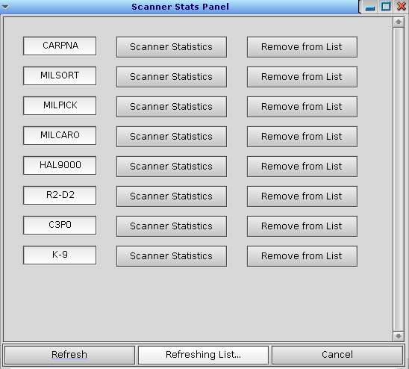

The screenshot above shows the Scanner Stats Panel. This window can be moved and resized as desired; position and dimensions will be preserved. It is divided into two main sections:
- Machine List – this section displays Automation Controller machines, each with the following three controls
  - Label – the Machine name, retrieved from the Machine menu. This field cannot be edited.
  - “Scanner Statistics” Button – this button launches the Scanner Statistics Display program for the respective machine
  - “Remove from List” Button – this button removes the entry from the Machine List section
- Administrative – this section contains buttons and status for managing the panel
  - “Refresh” Button – this button clears the Scanner Stats Panel and repopulates it by reading the Machine menu and creating an entry for each Automation Controller found
  - Status Label – this label provides status for the most recent operation
  - “Cancel” Button – this button closes the Scanner Stats Panel

Scanner Stats Panel Operation

First Use
When the Scanner Stats Panel is launched for the first time in a system, it will scan the Machine menu and create a row for each configured Automation Controller. If there are machines in the list that are not required, you may remove each by clicking the respective “Remove from List” button. If you later add more Automation Controllers to the system, you can include them in the Panel by clicking the “Refresh” button. This will repopulate the list with all Automation Controllers in the Machine menu. After conducting a “Refresh” operation, you will need to review the list of Automation Controllers again and remove any you do not wish to be displayed.

Launch Display Program
To launch the Display program for a machine, click the machine’s “Scanner Statistics” button. This will invoke the Display program, passing it the appropriate configuration data for the selected machine.
If a Configuration File has not yet been created for the machine, one will automatically be created.

Display Program Requirements
The Display program is launched from within the Scanner Stats Panel. This program requires two files for Scanner Statistics management:
- Configuration File (“Display.config.NODE”, where “NODE” is the name of the machine)
  - This file supplies the program with the information needed to find and modify the Data File.
  - If the file already exists, it will be loaded into the Display program.
  - If the file does not exist, it will be automatically created and passed to the Display program
- Data File (“Display.dat.NODE”, where “NODE” is the name of the machine)
  - This file contains the Scanner Statistics configuration data created by the Display program configuration window.
  - If the file already exists, the data will be loaded into the Display program.
  - If the file does not exist, it will be created once you have completed your configuration within the Display program.

File Distribution
As described in Section 2 above, once the Configuration Files and Data Files have been created on all respective machines, they need to be distributed so that each Machine has a complete (and identical) set of files so that data for all machines can be viewed from any single Automation Controller. The Scanner Stats Panel will automatically create “.config.” files if need be, so you are only required to distribute the Data Files (“.dat.NODE”) once they have been completed on the respective node.

Example Use
This example will describe the steps required to configure Scanner Statistics for a fresh Automation Controller.

- Launch the Scanner Stats Panel (Operator Menu… | Statistics Utilities… | Scanner Statistics)
The panel is populated with all Automation Controllers in the Machine Menu, shown in the screenshot below:



- For this example, only MILSORT and MILPICK will be configured for Scanner Statistics. We will start on the MILSORT node. Click the “Remove from List” button for all machines but MILSORT and MILPICK. The panel should look like the screenshot below:

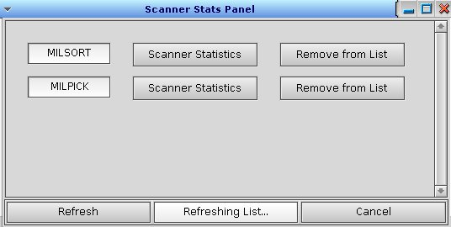

- Click “Scanner Statistics” for MILSORT. The Display program will be launched with an empty configuration. Use the Display program as you normally would to create the scanner statistics configuration file (“Display.dat.MILSORT”).
- Move to the MILPICK node.
- Launch the Scanner Stats Panel and trim the list down to MILSORT and MILPICK as described in step 2 above.
- Click “Scanner Statistics” for MILPICK. The Display program will be launched with an empty configuration. Use the Display program as you normally would to create the scanner statistics configuration file (“Display.dat.MILPICK”).
- Distribute the Data Files by copying the “Display.dat.MILPICK” file to the MILSORT node and the “Display.dat.MILSORT” file to the MILPICK node. Be sure to copy these files into the /SortPlus/RUN directory.
- Your system is now configured for Scanner Statistics shared among MILSORT and MILPICK.
  - Click “Scanner Statistics” for either machine from either node and verify proper display.

